Technical Report – DataOrbit Healthcare Provider Fraud Detection

1. Introduction
Healthcare fraud is a critical issue costing billions annually. This project focuses on building a machine learning pipeline to detect fraudulent Medicare providers using multi-table claims data. The goal is to design an interpretable fraud detection system with high recall and precision, while handling severe class imbalance.
This report follows the required structure and naming conventions, covering:
- Data Understanding & Exploration
- Feature Engineering & Aggregation Strategy
- Class Imbalance Handling
- Modeling & Comparison
- Evaluation, Error Analysis
- Conclusions
2. Dataset Description
The project uses the Healthcare Provider Fraud Detection dataset from Kaggle. It consists of four CSV files:
- Train_Beneficiarydata.csv – patient demographics and chronic conditions.
- Train_Inpatientdata.csv – inpatient claims (financial and procedural).
- Train_Outpatientdata.csv – outpatient claims.
- Train_labels.csv – provider-level labels (Fraud: Yes/No).
Key Identifiers:
- BeneID connects beneficiaries to claims.
- Provider connects claims to fraud labels.
3. Data Understanding & Exploration
-Dataset Relationships
- Beneficiaries → Claims (Inpatient & Outpatient) joined through BeneID.
- Claims → Providers → Fraud Label joined through Provider.
The modeling unit is Provider-level, so all claim-level information must be aggregated.
-Data Quality Checks
- Missing values found in chronic conditions.
- Numerical fields contain outliers (e.g., Claim Amount).
- Some provider claim counts extremely high (potential fraud indicator).
-Exploratory Findings
- Fraudulent providers tend to have:
  - Higher number of claims.
  - Higher average claim amounts.
  - More inpatient claims per beneficiary.
  - More chronic conditions among their beneficiaries.
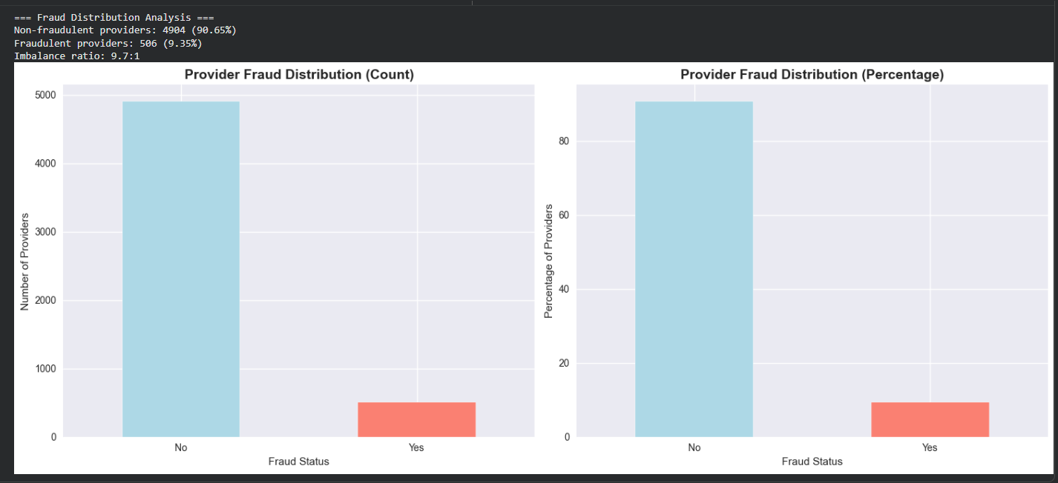
4. Feature Engineering & Aggregation
We created provider-level features by aggregating inpatient and outpatient tables.
-Aggregation Strategy
For each provider:
- Count Features: total claims, inpatient claims, outpatient claims.
- Financial Features: mean, sum, max claim amounts.
- Beneficiary Features: number of unique beneficiaries, average chronic conditions.
- Ratios: inpatient/outpatient ratios, claim-per-beneficiary ratios.
This aligns with Medicare auditing patterns.
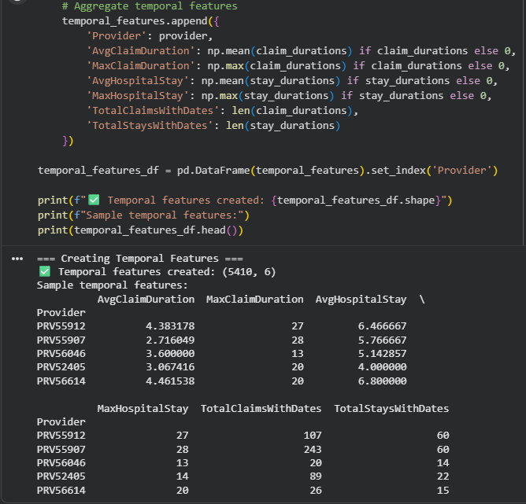
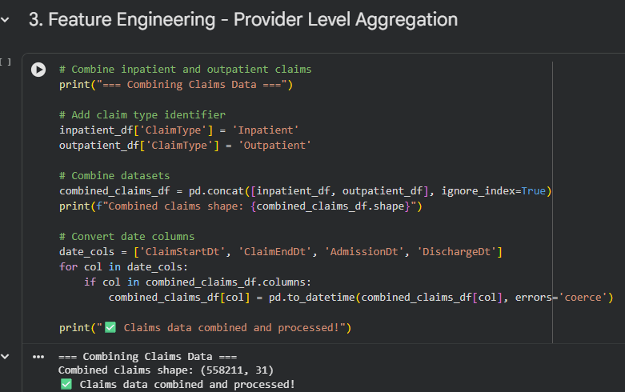
5. Handling Class Imbalance
Fraud cases ≈ 10%, creating severe imbalance.
We tested the following:
- Class weights (best-performing choice).
- SMOTE oversampling (added noise, not preferred).
- Undersampling (loss of information).
Final decision: class-weighted models to reduce false negatives without oversampling.
6. Modeling
We trained and compared:
- Logistic Regression
- Random Forest
- Decision Tree
- SVM
- XGBoost (best overall)
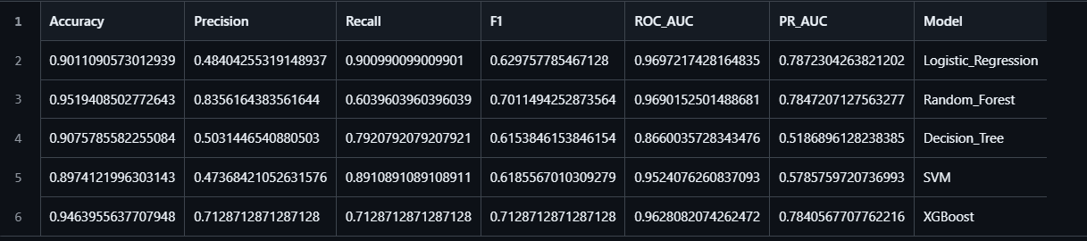
-Final Model Comparison Table
-Model Justification
- XGBoost offers the best balance of precision and recall.
- Handles non-linear relationships well.
- Works well with class imbalance (scale_pos_weight).
- Feature importance improves interpretability.

7. Evaluation
-Confusion Matrices
-ROC & PR Curves
These curves support final model selection.
-Error Analysis
False Positives (legitimate labeled as fraud):
Common patterns:
- High volume of claims with moderate amounts.
- High # of chronic conditions per beneficiary.
False Negatives (fraudulent but missed):
Patterns:
- Low claim amounts but high frequency.
- Slightly unusual but not extreme financial patterns.
Insights:
- Including temporal features (seasonal billing spikes) may reduce FN.
- More granular procedure-level aggregation could reduce FP.
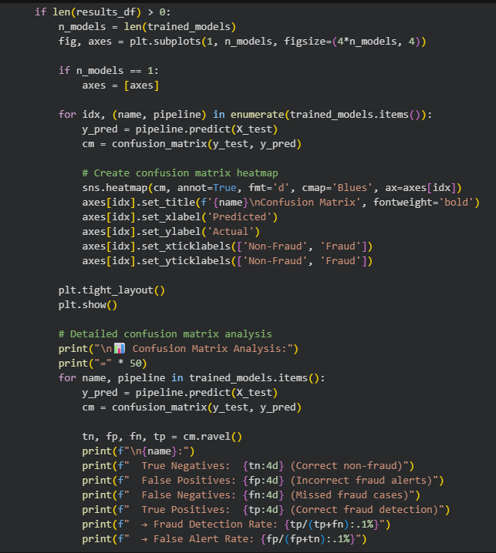

8. Conclusions
- Combining inpatient and outpatient patterns significantly improves predictive ability.
- XGBoost delivered the best fraud-detection performance.
- Class weighting was essential to balance precision/recall.
- Error analysis suggests additional features could further reduce false predictions.

